# **Plant experiments, day 1**

Slaven Cvijetic, Lester Frei, Ali Rahmany, Basil Rast

**Abstract:** Several different experiments were conducted, regarding plant metabolism plant growth and plant hormone. To name just a few examples, the effect of a plant hormone on the growth rate of plants was conducted. Another experiment, which investigated the enzymatic activity of DPE1 was assessed and an experiment, concerning the different growth rate of different plants in light and dark conditions was conducted. This string of experiments should lead to a better understanding of plants in general and to emphasise different crucial aspects of plant metabolism and plant hormone.

## Experiment C4.1: Polar regeneration of auxin-induced adventitious roots in hypocotyls of beans

### Introduction [1][2][3]

Auxin is a phytohormone, which has some important roles in the growth of plants. One of the most frequent auxin in nature is Indole-3-acetic acid (IAA). IAA is present in all plants but only **in** small amounts (1 – 100 µg per kg plant material). IAA is made from the amino acid tryptophan at the tip of plants (where new plant parts arise) and then transported to the bottom of the plants, to the roots. This is achieved by passive and active transport. If auxin is transported over a long distance, it happens basipetally in the phloem. Over short distances, symporters are playing a big role. IAA influences the growth of roots. If the concentration is higher than normal, the growth of primary roots is inhibited but the growth of adventitious roots reinforced. When the auxin concentration is lower than typical values, the whole root growth of a plant is decreased.

### Hypothesis

Adventitious roots will grow in the upper halves at the parts which had contact with the auxin solution. At the lower halves, which were in the auxin solution, the adventitious roots will **grow** where the original roots are. The seedlings which were placed in water, will grow roots at the cut location of the upper halves and the lower halves will just extend existing roots.

### Methods [3]

* bean seedlings were cut in half
* cut seedlings were placed in water or auxin solution for 2 hours (see picture)
* treated seedlings placed in petri dishes with wet filter paper
* petri dishes sealed up and kept dark
* growth phase of 1 week

### Results

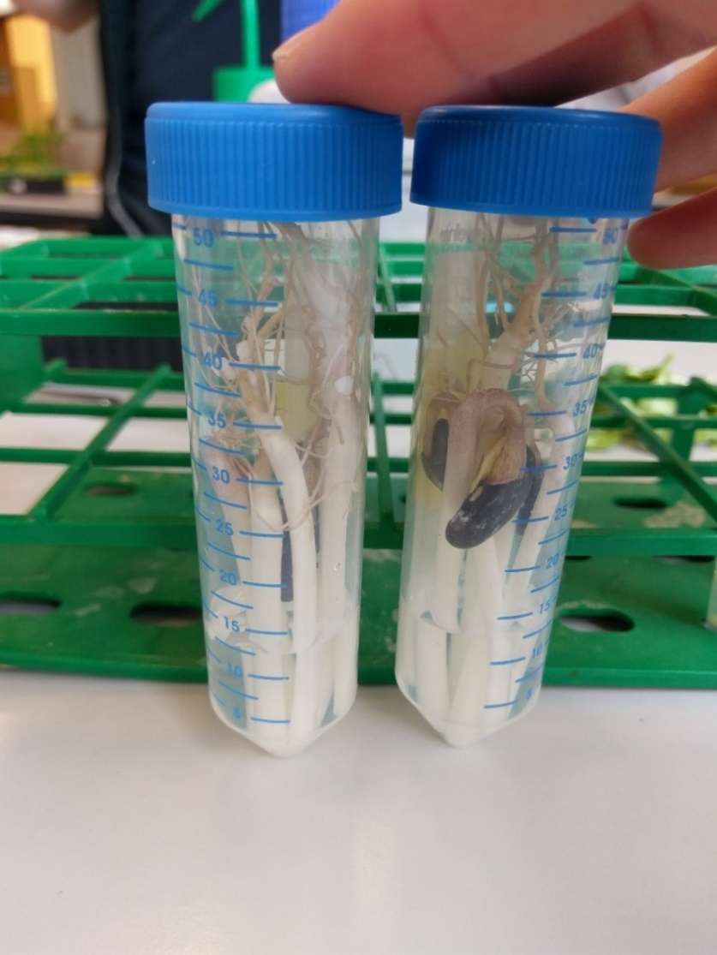

Figure 1: cut seedlings placed in water (left) and auxin

## Experiment C4.2: Comparison of internodal growth of dwarf and normal pea

### Introduction [4][5][6]

Peas (*pisum sativum*) are cultivated from humans for a long time. A lot of different breeds exist. Two of them are “Douche de Provence” and “Rapido”, which are used in this experiment. “Douche de Provence” peas belong to the dwarf peas, which are smaller than normal pea plants. The growth of plants is influenced by gibberellins like gibberellic acid (GA3). Gibberellins belongs to a big family of tetracyclic, diterpenoid growth regulators. A higher concentration of GA3 results in excessive organ elongation. When plants have specific mutations, it become insensitive to GA3. Plants who have such a mutation are labelled as dwarf plants, like “Douche de Provence” peas. The effect of GA3 to the growth of plants was already found in 1938, when a rice plant was infected with a fungus. The fungus produced GA3, which led to an excessive growth of stems. The increasing of the volume of the plant organs due to GA3 is achieved by cell expansion and higher cell division rates.

### Hypothesis

The normal peas will show a difference in growth of the internodes, due to the different treatment (GA3/control). The dwarf peas will not show a difference in the growth of the internodes due to the treatment.

### Methods [4]

* internodes of 5 plants of each different treatment were measured and marked
* plants were sprayed with control or GA3 solution
* plants are grown for 1 week

### Results

|  |  |  |  |  |  |  |  |  |
| --- | --- | --- | --- | --- | --- | --- | --- | --- |
| Plant/ Internode | Length internodes, normal pea, before GA3 treatment [mm] | Length internodes, normal pea, GA3 solution treatment [mm] | Length internodes, normal pea, before treatment [mm] | Length internodes, normal pea, control treatment [mm] | Length internodes, dwarf pea, before GA3 treatment [mm] | Length internodes, dwarf pea, GA3 solution treatment [mm] | Length internodes, dwarf pea, before treatment [mm] | Length internodes, dwarf pea, control treatment [mm] |
| 1/1 | 45 |  | 25 |  | 18 |  | 23 |  |
| 1/2 | 50 |  | 55 |  | 12 |  | 16 |  |
| 1/3 | 35 |  | 51 |  | 12 |  | 15 |  |
| 2/1 | 37 |  | 50 |  | 19 |  | 20 |  |
| 2/2 | 42 |  | 55 |  | 12 |  | 16 |  |
| 2/3 | 31 |  | -- |  | 14 |  | 13 |  |
| 3/1 | 36 |  | 35 |  | 17 |  | 19 |  |
| 3/2 | 49 |  | 48 |  | 13 |  | 14 |  |
| 3/3 | 33 |  | 52 |  | 13 |  | 14 |  |
| 4/1 | 41 |  | 53 |  | 22 |  | 20 |  |
| 4/2 | 52 |  | 42 |  | 17 |  | 13 |  |
| 4/3 | 22 |  | 54 |  | 9 |  | 12 |  |
| 5/1 | 43 |  | 48 |  | 20 |  | 22 |  |
| 5/2 | 63 |  | 52 |  | 15 |  | 11 |  |
| 5/3 | 23 |  | -- |  | 16 |  | 12 |  |

*Table 1*

C4.3. Tissue tension in sunflower hypocotyls

Introduction

In this experiment, we tried to examine the role of the epidermis in the regulation of osmosis. The epidermis is the most external cell layer of every plant and separates the plant or in this case the hypocotyls from the environment. It consists of several components. One of the components is the plant cuticle, a protecting film with similar properties like wax. The main function of the cuticle is the prevention of water evaporation, but by doing that it also stops water from entering the hypocotyl. [8]

As a result, there is less water in plant with a functioning epidermis compared to one without an epidermis. Water is a key element for plant growth and this is the focus of this experiment.

Hypothesis

Based on these facts, we assume that by peeling the epidermis of the hypocotyls, we facilitate the flow of water entering the plant and increase the growth.

Methods

10 seven-day-old sunflower seedlings were cut 1 cm long just below the cotyledons. The pieces were collected and incubated in a tube filled with distilled water for exactly two hours. After these 2 hours a strip of 1 to 2 mm width of the epidermis is peeled off with the flat tweezers.

At the same time, another person of the group was cutting 20 pieces of 2 cm length just below the cotyledons of sunflower seedlings. This time, all the pieces were split in two groups. The epidermis of one group were peeled off with flat tweezers, while the other weren’t changed. The peeled and unpeeled pieces were cut to a length of 1.5 cm. Once this was done, the two groups of hypocotyl pieces were put in 2 different tubes filled with water for 2 hours. [7]

Results

|  |  |
| --- | --- |
| **Length of the hypocotyl pieces** | **Length of the peeled epidermis strips** |
| 1cm | 0.9cm |
| 1cm | 0.7cm |
| 1cm | 0.85cm |
| 1cm | 0.9cm |
| 1cm | 0.95cm |
| 1cm | 0.8cm |
| 1cm | 0.9cm |
| 1cm | 0.9cm |
| 1cm | 0.8cm |
| 1cm | 0.8cm |

The differences in length can be explained by the (missing) accuracy in the peeling process.

|  |  |
| --- | --- |
| **Length of the unpeeled pieces (after 2 hours)** | **Length of the peeled pieces (after 2 hours)** |
| 1.5cm | 1.6cm |
| 1.5cm | 1.8cm |
| 1.5cm | 1.6cm |
| 1.6cm | 1.7cm |
| 1.5cm | 1.8cm |
| 1.5cm | 1.7cm |
| 1.5cm | 1.6cm |
| 1.5cm | 1.7cm |
| 1.5cm | 1.7cm |
| 1.6cm | 1.6cm |

The average length of the unpeeled pieces was 1.52 cm. The average length of the peeled pieces was 1.68 cm.

Discussion

The data indicates clearly that growth is dependent on the water flow and that the epidermis is a barrier, preventing water to enter.

## Experiment C4.4: Water potential measurement of potato parenchyma

Introduction

The general main context of this experiment is based on osmosis. Osmosis can be concluded as “*the spontaneous net movement of* [*solvent*](https://en.wikipedia.org/wiki/Solvent) *molecules through a* [*semi-permeable membrane*](https://en.wikipedia.org/wiki/Semi-permeable_membrane) *into a region of higher* [*solute*](https://en.wikipedia.org/wiki/Solution) *concentration, in the direction that tends to equalize the solute concentrations on the two sides*”.[9]   
The specific context of this experiment is to determine water potential of potato parenchyma. Potatoes (*Solanum tuberosum*) are starch storages. Even though, starch itself is not osmose active, the metabolites, derived from starch are. Therefore, osmosis is a highly crucial concept to understand the homeostasis of potatoes.

Hypothesis:  
The Hypothesis of the experiment is, that the higher the external concentration of sucrose, the lesser the weight of the potato slices. This hypothesis is based on some general knowledge about osmosis.

[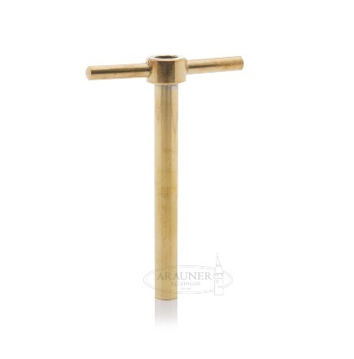](https://www.google.ch/url?sa=i&rct=j&q=&esrc=s&source=images&cd=&cad=rja&uact=8&ved=2ahUKEwi2pOKa-73ZAhULtBQKHWNlBi4QjRx6BAgAEAY&url=https://www.arauner.com/behaelter-zubehoer/fasszubehoer/225/korkbohrer-fuer-10-mm-loch&psig=AOvVaw1bXtg7f5rjbUryQkjD12_t&ust=1519541437124654)Methods:  
The plant material used in this experiment are potatoes.   
The materials/equipment used for this experiment are a cork driller, a scalpel, six falcon tubes, filter paper and a balance.   
The performed steps are as followed: Cylinders are cut out of raw potatoes with a cork driller. The cylinders are further cut into approximately 3 mm thick slices. Those slices are assembled in piles, so that each pile has a weight of approximately 2 grams. Those piles are then placed in different solutions. The solutions vary in their concentration of sucrose.   
After two hours, the weight of the slices is determined again.   
There were no modifications of the experimental setup.

Figure 2: This is a cork driller, such a cork driller was used to perform the experiment.[10]

Results:  
The obtained values are depicted in the following table and graph.

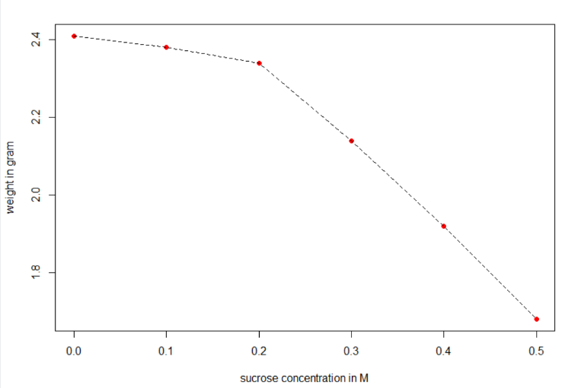

Figure 3: Relation between the weigth of the potato slices in gram and the sucrose concentration.

|  |  |  |
| --- | --- | --- |
|  | Initial weight | Final weight |
| Pure water | 2,01 gram | 2,41 gram |
| 0.1 M sucrose | 2,03 gram | 2,38 gram |
| 0.2 M sucrose | 2,02 gram | 2,34 gram |
| 0.3 M sucrose | 2,09 gram | 2,14 gram |
| 0.4 M sucrose | 2,04 gram | 1,92 gram |
| 0.5 M sucrose | 1,98 gram | 1,68 gram |

*Table 2*

Discussion

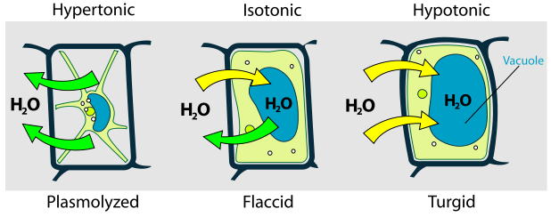The obtained data are consistent with the hypothesis. Therefore, the hypothesis cannot be depraved based on the collected data.   
The value at 3,77 M represents the concentration of sucrose, where the potato slices do not gain nor lose weight. This value can be concluded from the plot of the collected data. This value represents the point, where the potential of the solution and the potato are the same. This solution is called isotonic. Therefore, water does not leave nor enter the potato slices.   
When the potato slices are put in a hypotonic solution, the slices gain weight, because the water potential in the surrounding solution is higher than the water potential in the potato. Therefore, water enters the potato cells. When the potato slices are put in a hypertonic solution, the slices lose weight, because the water potential in the surrounding solution is lower than the water potential in the potato. Therefore, water leaves the potato cells.

Figure 4: This figure depicts the different relations between external solutions and cells.[3]

## Experiment C4.5: Comparison of development in light and dark

Introduction

This experiment was performed, to investigate the growth of different plants in light and darkness. Three different plants were used (peas, barley and mustard).

Hypothesis  
  
The hypothesis is, that the plants under the light conditions grow significantly better, than the plants under the dark conditions. This hypothesis is based on some general knowledge of photosynthesis, especially the part of photosynthesis, which requires light.

Methods

The plant materials used in this experiment were different kind of plant seeds. More specifically, pea, barely and mustard seeds were used.   
The materials/equipment used for this experiment were two black trays, vermiculite and approximately 0.2 liter of deionized water.   
The performed steps were as followed: At first, the holes of the trays were closed with some tape. Afterwards, the two trays were filled with vermiculite. In a next step, water was added to the trays, so the vermiculite turned from a sand like form into a somewhat solid structure.  
Then, 10 seeds of every plant were planted in a section of both trays. The mustard seeds were planted in a depth of approximately 1 cm. The barley seeds were planted in a depth of approximately 2 cm and the pea seeds were planted in a depth of approximately 3 cm.   
One of the two trays was then placed under light conditions, while the other tray was placed under dark conditions. The growth rate will be determined after two weeks under dark, respectively light conditions.

C31.1. Estimation of starch content by lugol staining

Introduction

The aim of this experiment is to find the synthesis site of starch in a plant leaf. Furthermore, we examine the phenotype of wild-type leaves of Arabidopsis and the dpe1 mutant that are incapable of metabolizing starch by lugol staining.

Starch is a polymer of glucose connected by glyosidic bonds. It serves as an energy storage and is produced during photosynthesis. As a result, all of the starch must be produced throughout the day and will be used as an energy source and will be metabolized in the night, when there’s no light for photosynthesis.[11] Starch has a helical structure and uses glucose and if available Iodide as building blocks.[12] The lugol solution, which is added at some point of the experiment, contains Iodide and indicates therefore the site where starch is synthesized by staining these spots on the surface of the leaf.

The leaves given to us by the assistants were harvested at an unknown time. This experiment can determine roughly the time, though.

Hypothesis

If the WT leaves were harvested late at night, the surface of the leave would be bright because there is no starch left to be colored by the lugol solution. In conclusion, the surface is going to be colored very dark at the end of the day because at the amount of starch is then at its peak due to continuous photosynthesis throughout the day. The mutant leaves are going to be dark anyway because these leaves cannot metabolize starch.

Methods

The plants, contained in ethanol, were harvested and prepared by the assistants. Then, one WT-plant and one dpe1-mutant were taken, washed with water and put in a petri-dish. The petri-dish is filled with lugol and left for ideally a couple of minutes, but we left it for about an hour there. After that period of time, both leaves were washed twice and therefore dark (stained) areas should be visible. [11]

Results and discussion

The dpe1-mutant turned out totally black, which means that there is a lot of starch on the surface of the leaves. This result proves that starch couldn’t be disintegrated by enzymes. The WT leaves have some dark areas but the leaves are not fully dark. These leaves were probably harvested one or two hours after it got dark. Some of the starch, synthesized during the day, was by then metabolized.

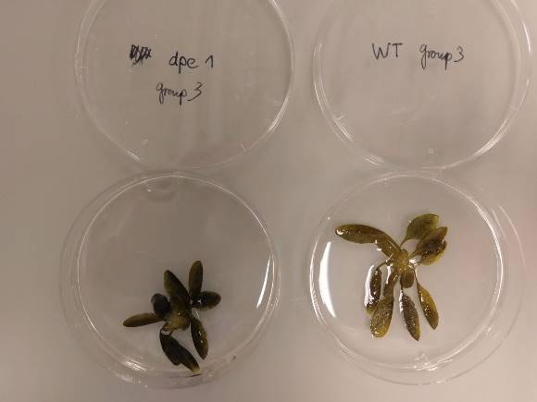

Experiment C31.1: Enzymatic activity assay

Introduction:

For this experiment, we will have a closer look on the starch metabolism in chloroplasts. Plants storage sugars in form of starch. The degradation of starch leads to two products. Either maltose or maltotriose is produced. Maltotriose is built up from three alpha-glucose subunits, which are linked, with an alpha-1-4 glycosidic bond. Maltotriose needs to be further processed, because there isn’t a transporter for maltotriose.   
The examined protein in this pathway is DPE1. DPE1 is a part of the degradation pathway, which transformed maltotriose into glucose. There also exists a mutant, which expresses *dpe1.*

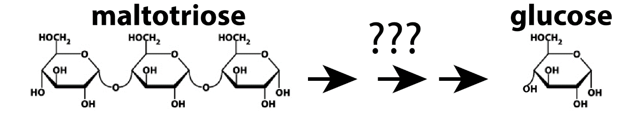

Figure 6: This figure depicts the overall process of maltotriose degradation [13].

Hypothesis:

The hypothesis is, that the DPE1, which is expressed in wild type plants, has a higher activity than *dpe1,* which is expressed in the mutant plant. Since the experiment was only conducted on the wild type, it will not be possible to confirm this hypothesis.

Methods:

At first, some plant extract needs to be produced. This requires grinding of plant leaves. After the addition of extraction buffer, the whole mixture needs to be put in a centrifuge. The supernatant than can be used in further experiments.   
A tube for the activity assay of the wild type protein and 5 microcentrifuge tubes for the aliquots is prepared. In order to prepare the activity assay of the DPE1, 180 µl H2O, 450 µl sodium acetate buffer and 90 µl maltotriose solution is mixed in a tube. Afterwards, 180 µl of the plant extract is added to the activity assay tube, therefore starting the reaction. The entire mixture is incubated at 37 °C. After 5, 10, 15, 20 and 30 min, 100 µl of the aliquot is pipetted into a separate microcentrifuge tube and incubated at 95°C for 3 min. This leads to the inactivation of the enzyme, therefore stopping the reaction. After the incubation at 95°C for 3 min, the microcentrifuge tubes are placed on ice.   
In order to determine the zero point conditions, 20 µl of the plant extract is incubated at 95°C for 5 min, therefore denaturating the enzyme and subsequently inactivating it. After this step, 20 µl H2O, 50 µl sodium acetate buffer and 10 µl maltotriose is added to the boiled plant extract.   
  
In a next step, the extinction coefficient is determined. Therefore, the extinction coefficient is determined before and after the addition of glucose-6P dehydrogenase (G6PDH).   
This data can be used to determine the initial amount of glucose.   
The steps necessary are as following. The addition of glucose-6P dehydrogenase leads to the formation of 6-P Gluconate. Interesting fact: This step also occurs in the human body, more specific, it is the first step of the pentose-phosphate pathway.   
As a side product of this step, NAD+ is reduced to NADH. NADH has a very distinct absorption. NADH absorbs light at 380 nm. After an incubation time of 20 min at room temperature, the absorption coefficient is measured. This value can be used to determine the amount of NADH. Because the production one NADH also needs one Glucose, the initial amount of Glucose can be deduced.

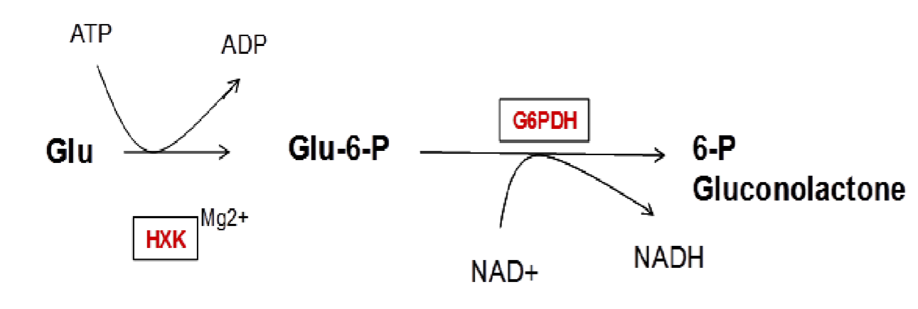

Figure 6: Shown are the two mentioned steps, which are necessary for the determination of the amount of glucose [13]

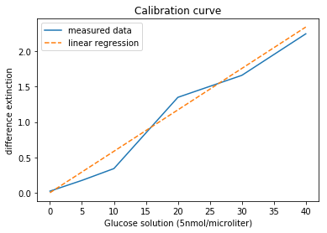Calibration cruve

Results:

The obtained values are depicted in the following table. The graph shows the relation between the difference between start and end extinction (y-axis) and time (x-axis)

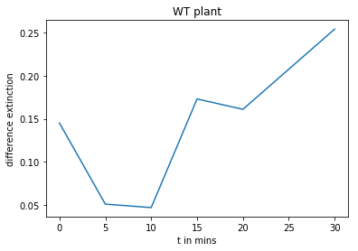

|  |  |  |  |  |  |  |
| --- | --- | --- | --- | --- | --- | --- |
| **WT** | **Zero point** | **5min** | **10min** | **15min** | **20min** | **30min** |
| Start extinction | 0.095 | 0.064 | 0.067 | 0.077 | 0.096 | 0.051 |
| End extinction | 0.240 | 0.155 | 0.144 | 0.250 | 0.257 | 0.305 |

Discussion:

The obtained values are highly inconsistent. This fact might have different origins. There is the possibility, that the buffer was prepared wrong, so that the pH value was to high, so the enzyme could not work efficiently. Another source for the inconsistent values might be   
Unfortunately we only performed the experiment on the wild type plant, so that we do not have any possibility to compare the values with the mutant.

## Experiment C31.2: Systemic gene silencing in *Nicotiana benthamiana* plants

### Introduction [1][2]

Gene expression can be influenced by RNA silencing. This means, mRNA is transcriptional or post-transcriptional influenced by miRNA or siRNA. The consequence is, that the mRNA can’t be further processed and the protein, for which the mRNA is coding will not be produced. There are a lot of different techniques to achieve a RNA silencing. One possibility is the use of *Agrobacterium tumefaciens*, which is a soil-borne bacterium. The WT causes the crown gall disease in plants. A horizontal gene transfer mechanism, which leads to silencing of a specific gene, is responsible for this disease. The mechanism can be altered in the labour. So, other genes of interest can be silenced and the effect for the organism can be studied. Two modified bacteria lines are used in this experiment to silence specific genes. *Agrobacterium tumefaciens* are able to insert their own DNA into plant cells. The product of inserted DNA is typically siRNA or miRNA, which binds to specific mRNA. The binding leads to the degradation of the mRNA and finally to the above descripted effects.

### Hypothesis

The GFP-expressing plant, which was infiltrated with the Agro-gffg suspension, will not fluorescence. The one which was infiltrated with mock will fluorescence.

When a WT plant is infiltrated with Agro-TRV-PDS, the leaves are bleached. If it was infiltrated with mock, no change is observed.

### Methods [1]

* each bacteria culture was centrifugated
* supernatant discarded
* pellet resuspended in MgCl2
* because the up and down pipetting was forgotten, the pellet resuspended not at first try. So, about a half of the MgCl2 in the tubes have been removed and then the pipetting was done. Afterwards the tubes were filled up again with MgCl2.
* measured optical density
* because OD600nm < 0.8, the remaining culture wasn’t diluted more
* acetosyringone added (µl 6 acetosyringone to 6 ml bacterial suspension)
* incubated 1 hour at RT
* the two types of plants were infiltrated with mock or an Agrobacterium suspension

### Results

**Optical densities:**

Agro-gffg: = OD600nm 0.664

Agro-TRV-PDS: OD600nm = 0.575

### Discussion

An explanation for the low optical density without dilution is, that the removed half of the solution of MgCl2 (see methods) already contained some Agrobacteriums, which afterwards were lost.

### References

[1] Wolff P.; Ottenschläger I.; Palme K. Auxin-Signaltransduktion bei Pflanzen Biospektrum **2003**, 5, 577 – 580

[2] http://www.chemie.de/lexikon/Auxine.html, accessed 24.02.2018

[3] Script Practical: Fundamentals of Biology II, plant physiology part, Department of Biology, Institute of Molecular Plant Biology

[4] Script Practical: Fundamentals of Biology II, plant physiology part, Department of Biology, Institute of Molecular Plant Biology

[5] https://de.wikipedia.org/wiki/Erbse, accessed 24.02.2018

[6] Santner A.; Calderon-Villalobos L. I. A.; Estelle M. Plant hormones are versatile chemical regulators of plant growth Nature Chemical Biology 2009, 5, 301-307

[7] [Eamens](https://www.ncbi.nlm.nih.gov/pubmed/?term=Eamens%20A%5BAuthor%5D&cauthor=true&cauthor_uid=18524877) A.; [Wang](https://www.ncbi.nlm.nih.gov/pubmed/?term=Wang%20MB%5BAuthor%5D&cauthor=true&cauthor_uid=18524877) M.; [Smith](https://www.ncbi.nlm.nih.gov/pubmed/?term=Smith%20NA%5BAuthor%5D&cauthor=true&cauthor_uid=18524877) N.A.; Waterhouse P.M. RNA Silencing in Plants: Yesterday, Today, and Tomorrow Plant Physiology 2008, 147, 456 – 468

[8] <http://m.flexikon.doccheck.com/de/Iod-St%C3%A4rke-Nachweis>  
[9] <https://en.wikipedia.org/wiki/Starch>  
[10] <https://en.wikipedia.org/wiki/Osmosis>  
[11]<https://www.google.ch/search?q=korkbohrer&source=lnms&tbm=isch&sa=X&ved=0ahUKEwiHz9iL-73ZAhVLVhQKHWcTAWcQ_AUICigB&biw=1244&bih=723#imgrc=8uYqY7nNCEFoCM>:   
[12] https://en.wikipedia.org/wiki/Epidermis_(botany)  
[13] file:///C:/Users/leste/AppData/Local/Packages/Microsoft.MicrosoftEdge_8wekyb3d8bbwe/TempState/Downloads/Day1_C31%20(1).pdf